

**Product Dissection for LinkedIn**

**Company Overview:**

LinkedIn is the world’s largest professional networking platform, designed to connect individuals, businesses, and professionals across the globe. Launched in **2003** by **Reid Hoffman** and a team of co-founders, LinkedIn has grown to become a key tool for career development, job searching, professional networking, and learning. In **2016**, LinkedIn was acquired by **Microsoft**, which helped further expand its reach and integration into the Microsoft ecosystem, especially with products like **Microsoft Office** and **Azure**.

Today, LinkedIn has over **900 million members** from more than **200 countries**, making it a leading platform for professionals in almost every industry.

**Product Dissection and Real-World Problems Solved by Linkedin:**

LinkedIn is a professional networking platform founded in **2003** by **Reid Hoffman** and a group of co-founders. It has grown to become the world's largest network for professionals, with over **900 million members** across more than **200 countries**. The platform allows users to create and maintain professional profiles, which serve as digital resumes, while also providing tools for connecting with colleagues, potential employers, and industry leaders. LinkedIn is often seen as a cornerstone of career development, networking, and recruitment, making it a vital tool for both job seekers and businesses.

In addition to connecting professionals, LinkedIn has expanded its features over the years to include tools for job searching, talent acquisition, content creation, and professional development. The platform's **Job Search Engine** uses advanced algorithms to match users with relevant job opportunities based on their profile data, while **LinkedIn Learning** offers a wide range of online courses to help individuals develop new skills and enhance their employability. LinkedIn's ability to blend professional networking with personalized job recommendations and continuous learning opportunities makes it an invaluable resource for users at every stage of their career.

LinkedIn has also become a critical tool for businesses looking to recruit talent and build brand presence. Through **LinkedIn Recruiter**, employers can access detailed candidate profiles, search for potential employees using advanced filters, and even reach out to passive candidates who may not be actively looking for jobs. The platform's advertising tools allow businesses to promote their products and services through sponsored content, while its **Groups** feature fosters community engagement around shared interests and industries. With its powerful suite of tools and integrations, LinkedIn serves as a one-stop platform for both personal career advancement and business growth, contributing significantly to shaping the modern professional landscape.

**Case Study: Real-World Problems and Linkedin's Innovative Solutions**

**LinkedIn**, the world’s largest professional networking platform, has transformed how professionals connect, build careers, and discover opportunities. By combining networking, personal branding, and career development, LinkedIn addresses real-world challenges for job seekers, recruiters, and businesses. With its innovative tools for job searching, professional learning, and content sharing, LinkedIn has become a solution-driven platform that fosters career growth and meaningful professional connections.

**Problem 1: Difficulty in Professional Networking and Building Connections**

**Real-World Challenge**: Building a strong professional network has always been a key to career success. However, traditional methods—like face-to-face networking events, job fairs, or relying on personal connections—can often be inefficient and limiting. Professionals often struggle to find relevant connections, mentors, or potential collaborators, especially those from different industries or geographical regions.

**LinkedIn’s Solution**: LinkedIn’s **connections** feature allowed professionals to expand their network beyond immediate colleagues or classmates. Users can send **connection requests** to people they may not know personally but share mutual interests with. LinkedIn also introduced the concept of **follow**, allowing users to stay updated with industry leaders, companies, and thought leaders. Additionally, **LinkedIn Groups** allow members to join communities centered around common interests, industries, or goals, enabling deeper engagement and collaboration.

**Problem 2: Job Search Inefficiencies and Finding the Right Candidates**

**Real-World Challenge**: The traditional job search process can be overwhelming and inefficient. Job seekers often apply for dozens of positions through generic job boards, many of which don’t align with their skills or preferences. For recruiters, finding the right candidates from a sea of resumes can be both time-consuming and frustrating. Additionally, companies face challenges identifying passive candidates—individuals who may not be actively seeking a job but are open to new opportunities.

**LinkedIn’s Solution**: LinkedIn transformed the job search process with its **Job Search Engine**, which uses **AI-powered recommendations** to match candidates with relevant job openings based on their profile data, skills, and preferences. LinkedIn’s **Premium Career** plan further enhances this experience by offering detailed insights into job listings, company activity, and who viewed a user’s profile. For recruiters, **LinkedIn Recruiter** provides advanced search filters, allowing businesses to find candidates based on precise criteria such as skills, experience, education, and location. Moreover, **InMail** enables recruiters to reach out to passive candidates directly, expanding their pool of talent beyond active job seekers.

**Problem 3: Skill Gaps and Continuous Professional Development**

**Real-World Challenge**: As industries evolve and technology advances, the demand for new skills increases. Professionals are often caught in a race to keep up with changing industry standards, but traditional education and training systems can be slow, expensive, and difficult to access. This creates a significant challenge for individuals looking to stay competitive in their fields. Employers also face challenges in ensuring their employees have the necessary skills to perform effectively.

**LinkedIn’s Solution**: LinkedIn’s **LinkedIn Learning** platform offers thousands of **on-demand courses** on a wide range of topics—from software development and marketing to leadership and project management. These courses, taught by experts, allow users to acquire new skills at their own pace. Additionally, LinkedIn’s **Skill Assessments** feature lets users take short tests to verify their proficiency in specific areas and display their results on their profiles, giving them a competitive edge in the job market. For businesses, LinkedIn Learning offers **team subscriptions**, enabling companies to provide training resources for their employees, promoting continuous learning and skill development.

**Problem 4: Building a Personal Brand and Professional Visibility**

**Real-World Challenge**: In today’s competitive job market, simply having the right qualifications is not enough. Professionals need to **stand out** and make their personal brand visible to potential employers, clients, or collaborators. However, building a personal brand and gaining visibility in a crowded digital space can be difficult without the right tools.

**LinkedIn’s Solution**: LinkedIn has developed a robust platform for **personal branding** through features like **Profile Optimization, Content Sharing**, and **Recommendations**. Users can post updates, share **articles**, and **publish long-form content** on LinkedIn Pulse, positioning themselves as thought leaders in their field. **Endorsements** and **Recommendations** from colleagues and connections add credibility to their skills and experience, further enhancing their professional reputation. Additionally, LinkedIn allows users to **showcase projects**, **certifications**, and **accomplishments**, helping them create a comprehensive digital portfolio.

**Problem 5: Diversity and Inclusion in Hiring**

**Real-World Challenge**: Many organizations struggle with creating diverse and inclusive workplaces, often due to biases in hiring processes. Identifying candidates from diverse backgrounds or those who fit underrepresented groups can be a challenge for recruiters, leading to a lack of diversity in leadership and decision-making roles.

**LinkedIn’s Solution**: LinkedIn has taken several steps to promote **diversity and inclusion** in the workforce. The platform provides tools for **diverse talent recruitment** through advanced filters and targeted outreach. LinkedIn’s **Diversity Insights** allow employers to track diversity metrics in their hiring pipeline and ensure that they are attracting a wide range of candidates. Additionally, LinkedIn has created initiatives such as the **Economic Graph** to promote workforce inclusion by identifying and addressing barriers that underrepresented communities face in accessing job opportunities.

**Top Features of Linkedin:**

1. **Professional Profiles**  
   Create detailed online resumes to highlight your professional journey, including work experience, education, skills, and certifications. Showcase recommendations from colleagues, display projects, and customize your headline and summary to reflect your career goals.
2. **Connections and Networking**  
   Build meaningful professional networks by connecting with colleagues, mentors, and industry leaders. Engage with posts, follow companies or individuals for updates, and utilize the "People You May Know" feature to grow your network strategically.
3. **Job Search and Job Alerts**  
   Search an extensive database of job listings tailored to your skills and preferences. Set up alerts for specific roles, industries, or locations and apply seamlessly using your LinkedIn profile as a digital resume.
4. **LinkedIn Learning**  
   Access thousands of online courses across diverse fields such as technology, business, and soft skills. Learn at your own pace, gain certifications to display on your profile, and stay competitive in the job market.
5. **Recommendations and Endorsements**  
   Receive written recommendations from colleagues or supervisors to enhance your profile's credibility. Endorse skills of your connections and get endorsed in return, helping recruiters see your expertise at a glance.
6. **InMail**  
   Send direct messages to users outside your network to build connections with professionals or recruiters. Use personalized InMails to pitch your ideas, seek advice, or explore career opportunities, especially with LinkedIn Premium.
7. **Content Sharing**  
   Share updates, publish articles, and create long-form posts to position yourself as an industry expert. Engage with your audience through likes, comments, and shares, and grow your professional presence on the platform.
8. **Advanced Search Filters**  
   Find exactly what you’re looking for using advanced filters to search for people, companies, jobs, or content. Narrow results by location, industry, title, education, and more for precise results tailored to your needs.
9. **LinkedIn Recruiter & Talent Solutions**  
   Utilize powerful tools designed for recruiters to source top talent, track candidates, and manage job postings. Access advanced analytics and search capabilities to identify the best candidates for your hiring needs.
10. **LinkedIn Ads**  
    Create and manage ad campaigns to promote your brand, services, or products. Use sponsored content, text ads, or video ads targeted to specific demographics, job roles, or industries for maximum impact.
11. **LinkedIn Events**  
    Organize webinars, conferences, or networking events directly on the platform. Promote these events to your connections or target audiences, and foster professional interactions through live discussions and follow-ups.
12. **Salary Insights**  
    Research and compare salary ranges for various roles based on location, experience, and industry. Gain insights into compensation trends to negotiate better offers or explore career options with confidence.
13. **Company Pages**  
    Create and manage a dedicated page for your company to showcase its culture, achievements, and job openings. Share updates, industry news, and thought leadership content to attract and engage followers.
14. **LinkedIn Premium**  
    Unlock exclusive features such as detailed insights into who viewed your profile, advanced search options, and InMail credits. Access premium tools for job seekers or recruiters, including applicant insights and resume optimization tips.
15. **LinkedIn ProFinder**  
    Find skilled freelancers for your projects in areas such as graphic design, marketing, writing, or web development. Explore profiles, review portfolios, and hire professionals to bring your ideas to life.

**Schema Description:**

In a typical database schema for a platform like LinkedIn, multiple tables would represent different entities such as **users**, **connections**, **jobs**, **companies**, **posts**, **messages**,and **groups**. Below is a summarized schema description that outlines the key entities and their relationships in a system like LinkedIn.

**1. Users Table**

This table contains basic information about LinkedIn members.

* **user_id** (Primary Key): Unique identifier for each user.
* **first_name**: User's first name.
* **last_name**: User's last name.
* **email**: User's email address (used for login and notifications).
* **password_hash**: Hashed password for security.
* **headline**: Professional headline (e.g., "Software Engineer at XYZ").
* **location**: User’s geographic location (city, state, country).
* **profile_picture**: URL of the user’s profile photo.
* **industry**: The professional industry the user works in (e.g., Technology, Healthcare).
* **summary**: A short bio or professional summary.
* **contact_info**: Additional contact details like phone number.
* **date_joined**: The date the user created their LinkedIn profile.
* **membership_type**: Type of LinkedIn account (free or premium).

**2. Connections Table**

This table tracks the connections between users.

* **connection_id** (Primary Key): Unique identifier for the connection record.
* **user_id_1** (Foreign Key): The user who initiated the connection.
* **user_id_2** (Foreign Key): The user who accepted the connection.
* **status**: Connection status (e.g., Pending, Accepted, Declined).
* **connection_date**: The date when the connection was established.

**3. Jobs Table**

This table stores job postings made by companies or recruiters.

* **job_id** (Primary Key): Unique identifier for each job posting.
* **company_id** (Foreign Key): The company posting the job (references Companies table).
* **title**: Job title (e.g., Software Engineer, Marketing Manager).
* **description**: Detailed description of the job responsibilities.
* **location**: Job location (city, state, country).
* **skills_required**: List of skills required for the job.
* **salary_range**: Salary range for the position (if available).
* **post_date**: Date the job was posted.
* **application_deadline**: The date by which candidates must apply.
* **job_type**: Full-time, part-time, contract, etc.

**4. Company Table**

This table contains details about companies registered on LinkedIn.

* **company_id** (Primary Key): Unique identifier for each company.
* **company_name**: Name of the company.
* **industry**: Industry the company operates in (e.g., Tech, Finance).
* **company_size**: Size of the company (e.g., Small, Medium, Large).
* **company_website**: URL of the company’s official website.
* **company_logo**: URL of the company’s logo.

**5. Posts Table**

This table tracks posts made by users on their feed.

* **post_id** (Primary Key): Unique identifier for each post.
* **user_id** (Foreign Key): The user who created the post.
* **content**: Text content of the post.
* **media_url**: URL of any media (image/video) shared with the post.
* **created_at**: Date and time the post was created.
* **post_type**: Type of post (e.g., Update, Article, Shared Content).

**6. Recommendations Table**

This table tracks written recommendations between users.

* **recommendation_id** (Primary Key): Unique identifier for each recommendation.
* **from_user_id** (Foreign Key): The user who is giving the recommendation.
* **to_user_id** (Foreign Key): The user receiving the recommendation.
* **recommendation_text**: The text of the recommendation.
* **created_at**: Date and time when the recommendation was made.

**7. Messages Table**

This table stores messages sent between users (via InMail or direct messaging).

* **message_id** (Primary Key): Unique identifier for each message.
* **sender_user_id** (Foreign Key): The user who sent the message.
* **receiver_user_id** (Foreign Key): The user who received the message.
* **message_content**: The content of the message.
* **sent_at**: Timestamp when the message was sent.
* **status**: Read or unread status of the message.

**8. Skills Table**

This table holds skills associated with users and job postings.

* **skill_id** (Primary Key): Unique identifier for each skill.
* **skill_name**: Name of the skill (e.g., Python, Data Analysis).
* **skill_category**: Category to which the skill belongs (e.g., Programming, Soft Skills).

**9. User_Skills Table**

This table associates users with the skills they list on their profiles.

* **user_id** (Foreign Key): The user who has the skill.
* **skill_id** (Foreign Key): The skill possessed by the user.
* **proficiency_level**: User’s proficiency in the skill (e.g., Beginner, Intermediate, Advanced).

**10. Endorsements Table**

This table tracks endorsements of a user’s skills by others.

* **endorsement_id** (Primary Key): Unique identifier for each endorsement.
* **skill_id** (Foreign Key): The skill that is being endorsed.
* **endorsing_user_id** (Foreign Key): The user who is endorsing the skill.
* **endorsed_user_id** (Foreign Key): The user whose skill is being endorsed.
* **created_at**: Timestamp when the endorsement was given

**11. Groups Table**

This table contains LinkedIn groups created for professional discussions or networking.

* **group_id** (Primary Key): Unique identifier for each group.
* **group_name**: Name of the group (e.g., Data Science Professionals).
* **description**: Description of the group and its purpose.
* **admin_user_id** (Foreign Key): The user who created or manages the group.
* **created_at**: Date the group was created.

**12. Group_Memberships Table**

This table stores the relationship between users and groups they belong to.

* **user_id** (Foreign Key): The user who is a member of the group.
* **group_id** (Foreign Key): The group that the user is a part of.
* **membership_date**: Date the user joined the group.
* **role**: The role of the user within the group (e.g., Member, Admin).

**13. Ads Table**

This table stores information about LinkedIn ads that users or companies promote.

* **ad_id** (Primary Key): Unique identifier for each ad.
* **company_id** (Foreign Key): The company running the ad.
* **ad_type**: Type of ad (e.g., Sponsored Content, Text Ads).
* **content**: Content of the ad.
* **target_audience**: Demographics and job functions targeted by the ad.
* **start_date**: Date the ad campaign started.
* **end_date**: Date the ad campaign ended.

**14. Premium Subscription Table**

This table tracks premium subscriptions of LinkedIn users.

* **user_id** (Foreign Key): The user who has the premium account.
* **subscription_type**: Type of premium subscription (e.g., Premium Career, Premium Business).
* **start_date**: The date when the premium subscription started.
* **end_date**: The date when the subscription ends or renews

**15. LinkedIn Learning Table**

This table holds information about courses available on LinkedIn Learning.

* **course_id** (Primary Key): Unique identifier for each course.
* **course_name**: Name of the course (e.g., "Python for Data Science").
* **category**: The category of the course (e.g., Programming, Leadership).
* **instructor**: The instructor teaching the course.
* **duration**: Duration of the course (e.g., 5 hours).
* **completion_certificate**: Whether the course offers a certificate of completion.

**ER Diagram:**

Let’s design an ER diagram that illustrates the core entities and their relationships in the LinkedIn schema. This diagram will visually represent the fundamental elements of LinkedIn’s data structure, highlighting how users, connections, jobs, and other features interact. It provides a comprehensive view of the data flow and associations that power the platform's professional networking capabilities.

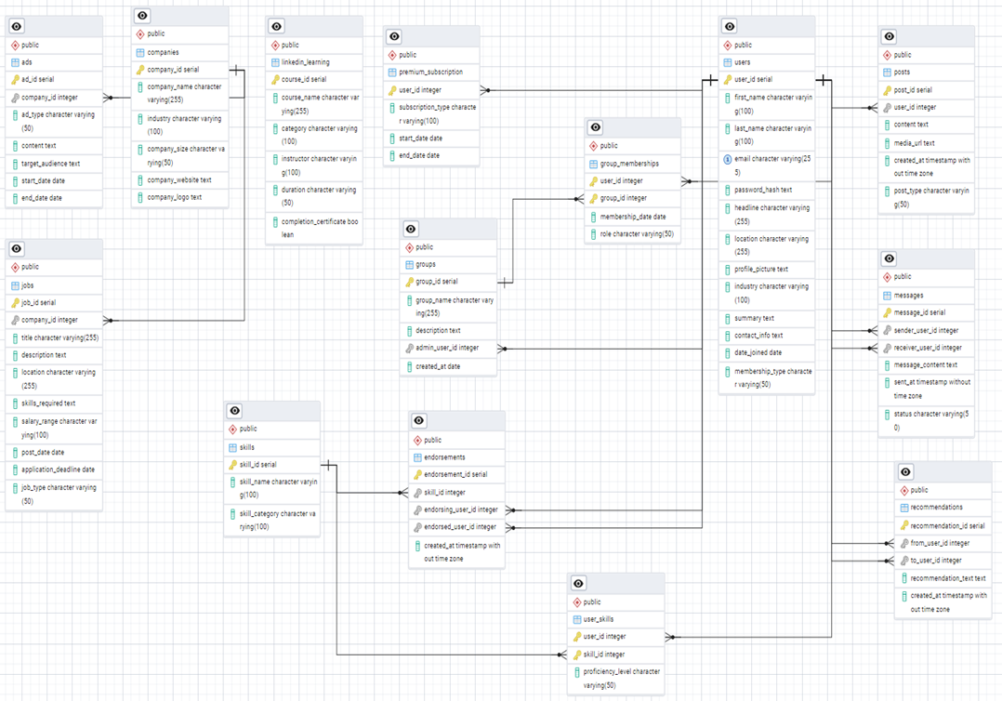

**Conclusion:**

This case study provided a comprehensive exploration of LinkedIn's data model and functionality. By analyzing and designing the schema, we gained a deeper understanding of how LinkedIn effectively connects professionals, facilitates job opportunities, and enhances skill development. The ER diagram highlighted the intricate relationships between users, jobs, connections, and other platform features, emphasizing LinkedIn’s role as a robust professional networking tool.Through this exercise, we also recognized the importance of scalability, user engagement, and data privacy in building a platform that supports millions of users worldwide. This study serves as a blueprint for creating data-driven applications that prioritize user-centric design and functionality.